**Semester: V (2023-24) Subject:** Communication Protocols

**Name: Class: TYEE**

**Roll No: Batch:**

**Experiment No: 02**

**Name of the Experiment**: Study of basic network configurations, settings and networking Commands: ping, ipconfig, tracert and related tools (open visual trace route).

**Performed on:**

**Submitted on:**



**Aim:** Tostudy the basic network configurations, settings and networking commands.

**Prerequisite:**

* Basic knowledge of data communications.

**Objectives:**

* To study and understand the basics of network configurations.
* To study and understand how the networking commands work.

**Components and equipment required/studied:**

Computer with Operating System installed (preferably Windows), Internet Connection, Virtual Trace Route application installed on the system.

**Theory:**

**Network Configuration:**

Network configuration allows a system administrator to set up a network to meet communication objectives. The process involves the following tasks:

* Router configuration: Specifies the correct IP addresses and route settings, etc.
* Host configuration: Sets up a network connection on a host computer/laptop by logging the default network settings, such as IP addressing, proxy, network name and ID/password, to enable network connection and communication.
* Software configuration: Any network-based software, like an intrusion detection system (IDS), is allowed access and provided with the appropriate credentials to monitor network traffic.

**Network Commands:**

1. ipconfig: ipconfig is a Console Command which can be issued to the Command Line Interpreter (or command prompt) to display the network settings currently assigned to any or all network adapters in the machine. This command can be utilised to verify a network connection as well as to verify your network settings.
2. ping: ping is one of the most basic yet useful network commands to utilize in the command prompt application. It tells you whether your computer can reach some destination IP address or domain name, and if it can, how long it takes data to travel there and back again.
3. tracert: tracert stands for Trace Route. Like ping, it sends out a data packet as a way to troubleshoot any network issues you might have, but it instead tracks the route of the packet as it hops from server to server.

**Procedure:**

1. Click on the start button and enter cmd in the search box and tap on **cmd** in results OR press **Windows + R** buttons and type **cmd** in the box and press the **OK** button.

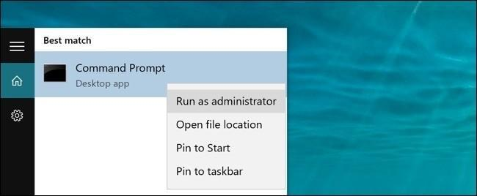

**Fig. 2.1 Opening the command prompt using Start Menu**

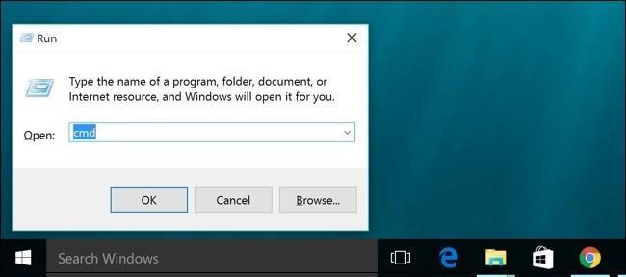

**Fig. 2.2 Opening the command prompt using the run box.**

**PART B: Working with ipconfig:**

Type ‘ipconfig’ in the command window and press Enter.

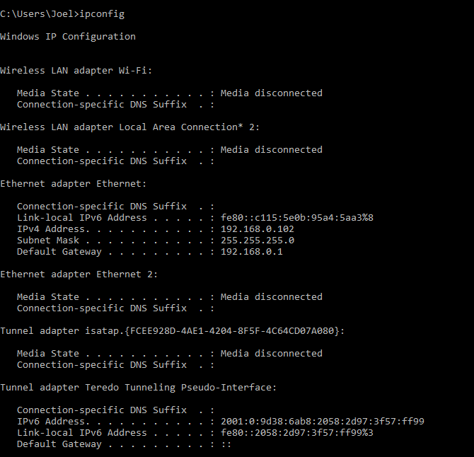

**Fig. 2.4 Sample Output for ipcofig command**

1. **PART A: Working with ping:**

Type ‘ping’ in the command window and ip address or the domain you want to ping.

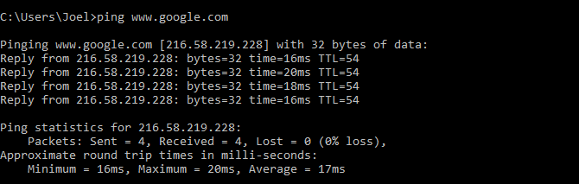

**Fig. 2.3 Sample Output for the ping command**

**PART C: Working with tracert:**

Type ‘tracert’ in the command window and press Enter.

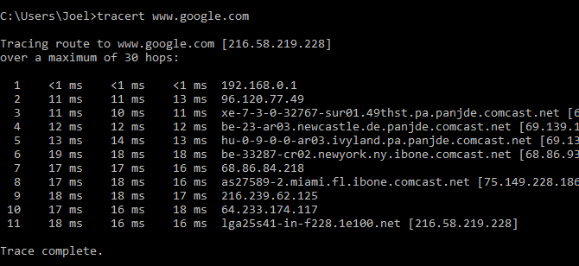

**Fig. 2.5 Sample Output for tracert command**

1. **Working with Visual Route:**
2. Open the ‘Visual Trace Route’ application.
3. Enter ip address or the domain.

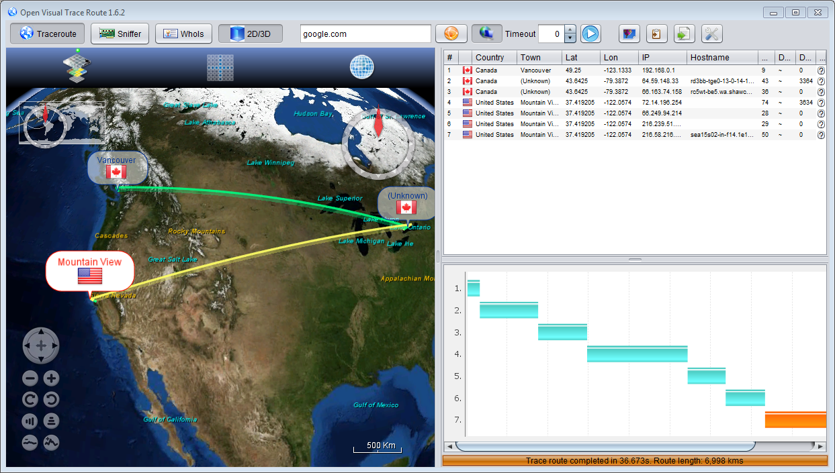

**Fig. 2.6 Sample Output for Visual Trace Route**

**Conclusion:** We studied the basic network configurations, settings and networking commands while performing this experiment.

**Post Lab Questions:**

1. Explain any three additional networking commands.
2. Find out the number of hops for your preferred website or IP address.
3. Ping any website or IP address of your choice and write the time required for all the packets to reach the destination. Write the reason due to which the packets take different time to reach the destination.